Logo:

(I did not design a logo because I want our logo to be SVG, and mine would be a PNG or JPEG)

### Fridge

<https://www.svgrepo.com/svg/368453/fridge>

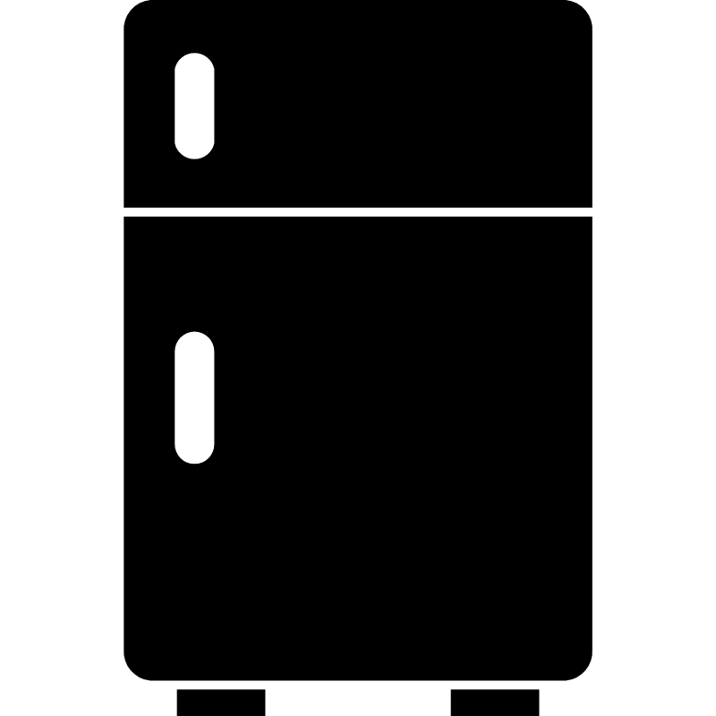

### Cornucopia - out because of fruit of the loom

<https://www.svgrepo.com/svg/322105/cornucopia>



### Chef - Final

<https://www.svgrepo.com/svg/520629/chef-cap> | <https://www.svgrepo.com/svg/525270/chef-hat>



# Brand Font:

### Option 1: |

<https://fonts.google.com/specimen/Josefin+Sans?lang=en_Latn&preview.text=Garde%20Manger&stroke=Sans+Serif>

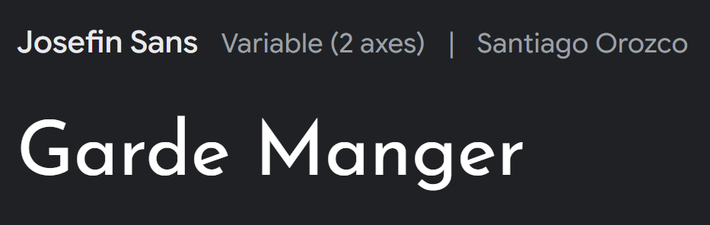

### Option 2: | | - Final

<https://fonts.google.com/specimen/Philosopher?lang=en_Latn&query=philo&stroke=Sans+Serif>

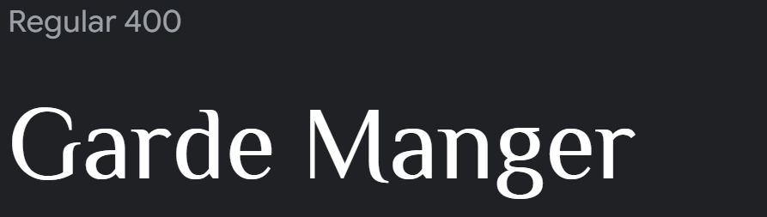

### Option 3: - ruled out

<https://fonts.google.com/specimen/Inria+Sans?lang=en_Latn&preview.text=Garde%20Manger&stroke=Sans+Serif>

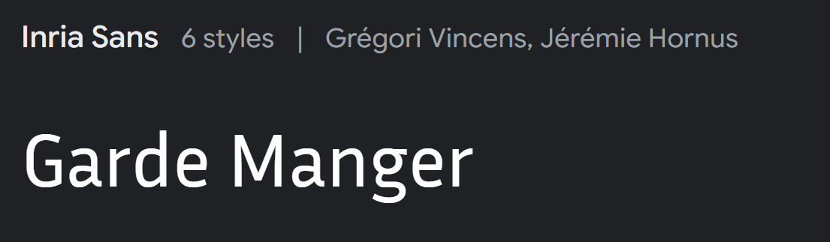

### Option 4: | |

<https://fonts.google.com/specimen/Julius+Sans+One?lang=en_Latn&stroke=Sans+Serif>

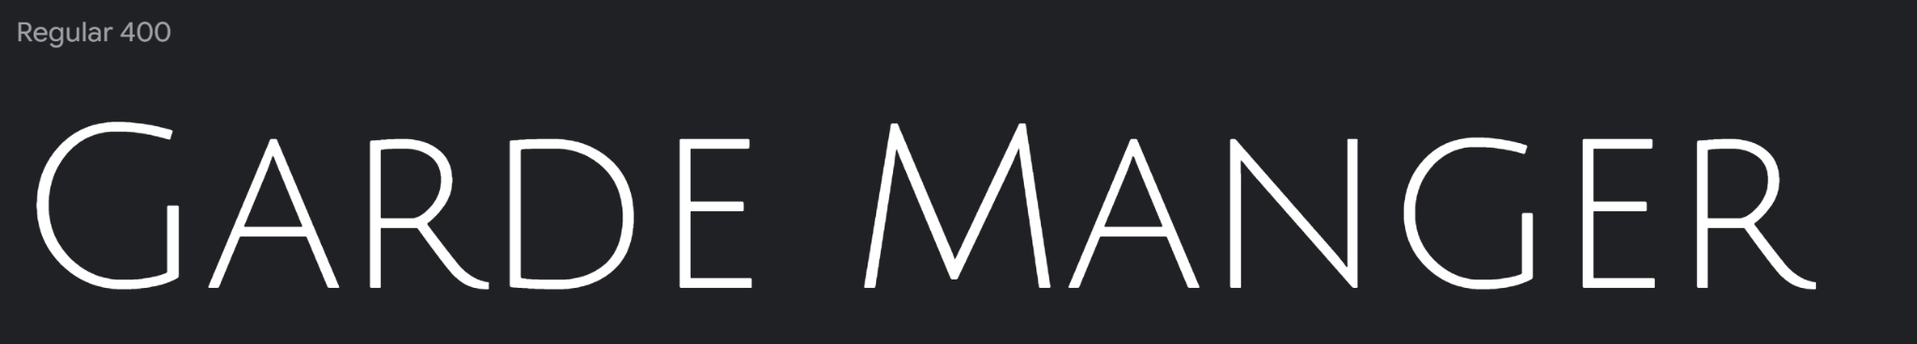

# Normal font:

### Option 1:

<https://fonts.google.com/specimen/Didact+Gothic?lang=en_Latn&stroke=Sans+Serif>



### Option 2: - Final

<https://fonts.google.com/?lang=en_Latn&stroke=Sans+Serif>

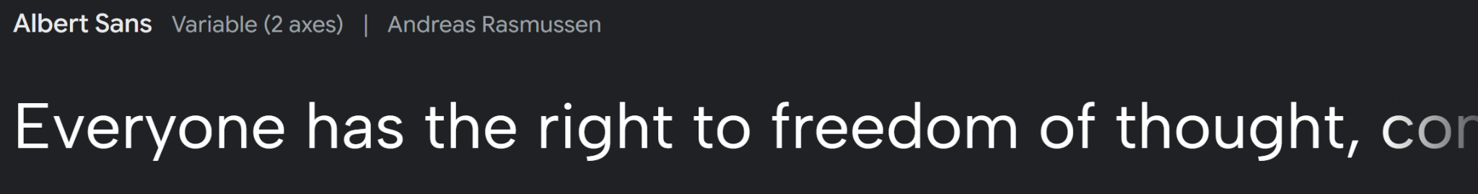

### Option 3:

<https://fonts.google.com/specimen/Abel?lang=en_Latn&stroke=Sans+Serif>



## 

## 

## 

## 

# Colors:

### Final:

<https://coolors.co/ffd651-0e3661-366aa3-b5e2fa-f9f7f3>

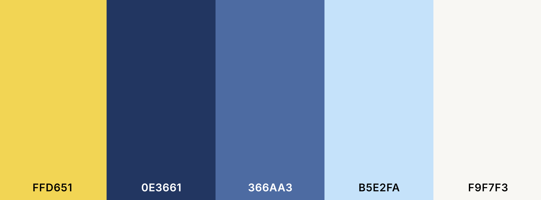

### Option 1: |

[Palette - Coolors](https://coolors.co/palette/0d3b66-faf0ca-f4d35e-ee964b-f95738)

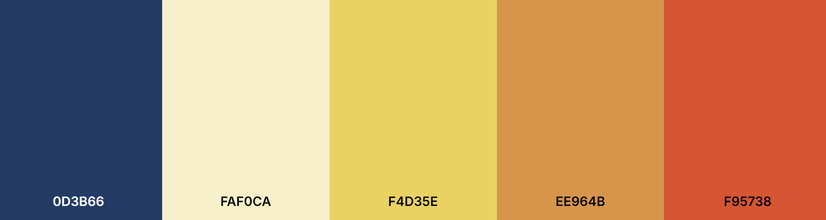

### Option 2:

<https://coolors.co/palette/fdc921-fdd85d-fffdf7-99d6ea-6798c0>

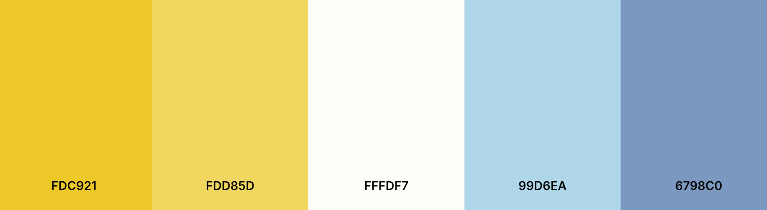

### Option 3:

[Palette - Coolors](https://coolors.co/palette/0fa3b1-b5e2fa-f9f7f3-eddea4-f7a072)

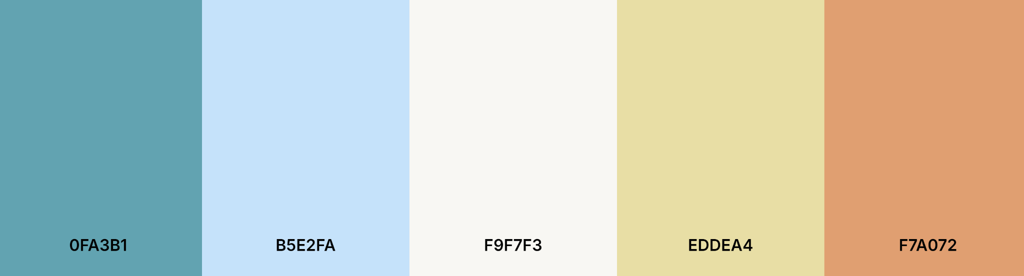

### Option 4:

<https://coolors.co/ffa400-009ffd-2a2a72-232528-eaf6ff>

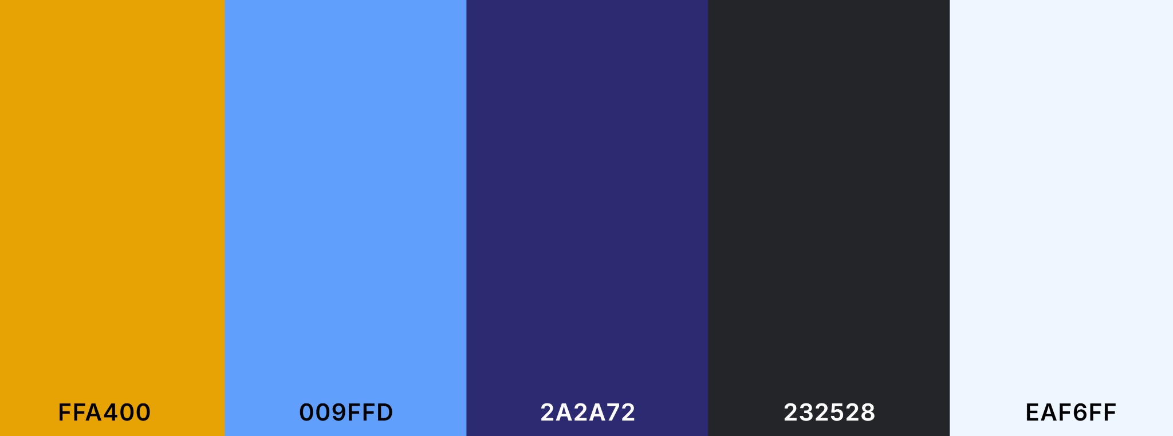

### Option 5:

<https://coolors.co/064789-427aa1-ebf2fa-679436-a5be00>

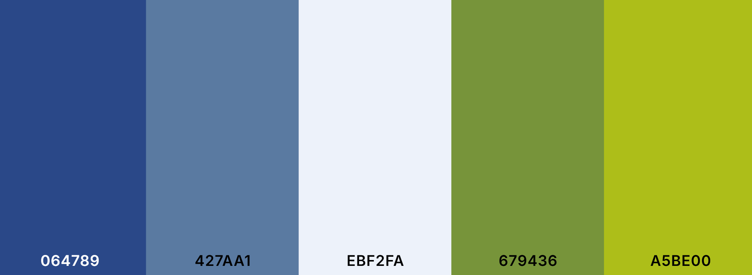

Final Branding

## Logo:

<https://www.svgrepo.com/svg/520629/chef-cap>



## Brand Font:

<https://fonts.google.com/specimen/Philosopher?lang=en_Latn&query=philo&stroke=Sans+Serif>

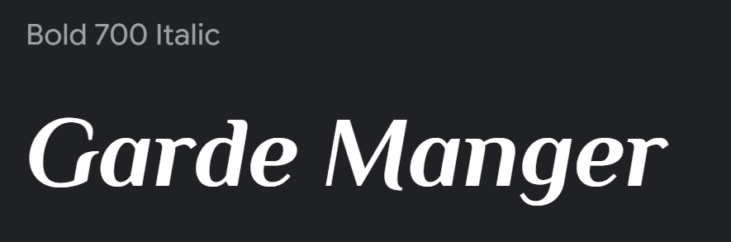

## Normal Font:

<https://fonts.google.com/?lang=en_Latn&stroke=Sans+Serif>



## Colors:

<https://coolors.co/ffd651-0e3661-366aa3-b5e2fa-f9f7f3>

